Progress Report Rubric
Brief Project Description
The primary motivation for this project is to improve digital accessibility for visually impaired individuals, for whom the internet remains largely opaque. While screen readers can vocalize text, they cannot interpret images lacking manual alt-text tags. An automated captioning system acts as a "visual interpreter," bridging this gap by converting pixel data into descriptive speech. Therefore, the objective of this project is to design and implement a custom Hybrid Encoder-Decoder architecture, capable of captioning images with coherent English sentences.
This task bridges two distinct data modalities: spatial data from images and sequential data from language. The input to our model consists of raw pixel data from images, which are resized to 224*224 pixels and normalized using ImageNet-based normalization. The target output is variable-length, grammatically coherent sequential text describing the image. Traditional rule-based algorithms fail to effectively address this mapping challenge. A deep learning approach is therefore essential as it learns a non-linear mapping between these two domains. Specifically, our architecture utilizes a Convolutional Neural Network (CNN) to compress the input image into a dense semantic "content vector," while a Recurrent Neural Network (RNN) leverages this spatial vector to generate the sequential text output.
Notable contributions:
Data Processing:
For our data processing pipeline, we utilized the Flickr8k dataset, which consists of approximately 8,000 images. To demonstrate independent data collection capabilities, I also incorporated 20 personal images taken over the past two months. All images were pre-processed and resized to 224*224 pixels to ensure a consistent input format for the Encoder-Decoder architecture. To match the structure of the primary dataset, I manually generated five descriptive captions for each of my 20 uploaded images, resulting in 100 new captions.
Using standard Python data analysis tools, I inspected the dataset to verify that every uploaded image had exactly five corresponding captions. I also conducted exploratory data analysis (EDA) to gain a holistic view of the text data, which included calculating the total number of tokens across the captions and analyzing their relative frequencies. This EDA is crucial for tracking and evaluating the sentences produced by the LSTM-based generator when evaluating unseen data. Finally, the primary dataset was split into training, validation, and test sets, with the 20 newly collected images and their corresponding captions added directly to the test set to evaluate the model's performance on entirely new data.

Baseline Model
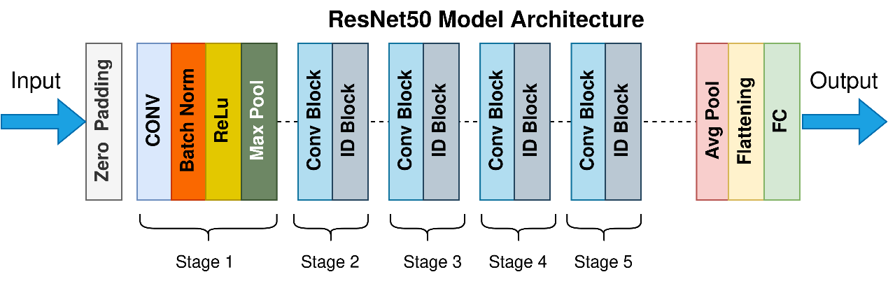
For our baseline, we implemented a K-Nearest Neighbors retrieval-based model leveraging a pre-trained ResNet-50 architecture. This serves as a non-generative benchmark, allowing us to evaluate how much our primary neural network is actually able to reason compared to a system that simply retrieves existing captions from visually similar scenes.
- Model Architecture and Mechanism
As illustrated in the model diagram, we utilize a pre-trained ResNet-50 Convolutional Neural Network. The input image is first processed through a zero-padding layer, followed by Stage 1, which applies Convolution, Batch Normalization, ReLU activation, and Max Pooling. The data then flows through Stages 2 to 5, which consists of a deep sequence of alternating Convolutional Blocks and Identity (ID) Blocks. Finally, the network utilizes Average Pooling and Flattening to output a dense feature vector. For our baseline, we downloaded the model with its pre-trained weights. Instead of using the final Fully Connected (FC) layer for classification, we extract the dense feature vector to represent the image's spatial features. Given a new test image, the model calculates the distance between its feature vector and all pre-computed vectors in the training set, ultimately assigning the primary human-written caption of the nearest neighbor (K=1) to the test image.
- Results and Challenges
Since the actual output of this model is text, we utilized standard quantitative NLP evaluation metrics to measure performance. Evaluating the baseline on our test set yielded the following quantitative results:
- BLEU-4: 0.0922
- CIDEr: 0.2563
Qualitatively, these relatively low scores reflect the limitations of a purely retrieval-based approach. While the KNN model successfully retrieves captions for images that closely match the training data, a notable challenge arises when a test image features a unique scene or combination of objects. If the test image is not close to any vector in the pre-computed database, the algorithm is still forced to retrieve the "nearest" neighbor, which assigns a highly inaccurate and contextually irrelevant caption to the test image. This forced retrieval is the primary challenge that our generative Encoder-Decoder model aims to tackle by synthesizing novel descriptions rather than simply copying existing ones.

Primary Model
For our primary model, we are implementing generative Hybrid Encoder-Decoder architecture. This serves as our core neural network, designed to synthesize novel, coherent English sentences to describe raw images, directly addressing the limitations of the retrieval-based baseline.
- Model Architecture and Mechanism
As illustrated in our updated architecture diagram, the model is split into two main components: an Encoder and a Decoder. The Encoder utilizes the convolutional layers of a pre-trained ResNet-50. However, unlike the baseline which extracts a single flattened feature vector, the primary model extracts spatial feature maps from the final convolutional layer to preserve regional image data. This spatial data is passed to a custom Decoder built with Long Short-Term Memory (LSTM) units, which are optimized for handling long-range dependencies in natural language. To bridge these two networks, we integrated a soft-attention mechanism. At each time step of sequence generation, the attention mechanism calculates a context vector, allowing the LSTM to dynamically weigh and focus on specific, relevant regions of the image while predicting the next word.
- Results and Challenges
Similarly, we use BLEU-4 and CIDEr scores to evaluate the model performance.

Qualitatively, the primary model demonstrates the ability to effectively "reason" by synthesizing completely new captions tailored to the specific spatial features of the test image, successfully describing novel combinations of objects rather than relying on pre-existing text. A notable challenge faced during implementation was tuning the soft-attention mechanism. Ensuring that the model correctly aligns its attention weights with meaningful visual subjects—rather than focusing on background noise or hallucinating objects—requires careful optimization of the model's hyperparameters to prevent the LSTM from overfitting to dominant linguistic patterns found in the training data.

